**Name :- Vineet Kumar Pandey**

**Project Name:-**

**AIR TICKET BOOKING SYSTEM**

DAV POST GRADUATE COLLEGE

Varanasi,Uttar Pradesh

**Father’s name :-Anil Kumar Pandey**

**Dob :- 15th of march ,2003**

**Course :- UGDCA**

**Roll No. :- 20836DA407**

**Submitted to :- Mrs. Kaveri Sharma**

**Enrollment no. :- 425895**

**Index**

1. Acknowledgement
2. Preface
3. Objective
4. Declaration
5. Scope of the project
6. Introduction to project
7. Tools Used
8. Flowchart
9. Project coding and Output
10. Conclusion
11. Bibliography

**Acknowledgement**

It is great privilege to record my deepest sense of gratitude to all the people who have stood by me through out of making of this project.

This is a token of gratitude that firstly goes to, The head of Department of Computer Science **Dr. NAZAM ZAMAN**

for his benevolent guidance, heart full encouragement & constructive counselling that helped me immensely for the execution of this project.

I also put my effort to our course coordinator **Mrs. Kaveri Sharma**

I have learned and benefited a lot from her suggestions.

I am also indebted to my team members for their constructive criticism and constant support in design and implementation of this project.

Finally, my gratitude goes to all the family members and friends for their perseverance and cooperation with all their blessings. Without their support project will not take its present shape. Hope, you will appreciate this effort of mine.

Name :-

**Preface**

Project work is the most important activity of ‘UGDCA’. This provides us an opportunity to apply our knowledge, skills and aptitude in real life.

Project prepared should be technical in nature because technical project can be much more easily then, the theoretical one. Project planner should be well trained and have a good knowledge about the project I was supposed to develop an **Air ticket booking system**.

In my project preparation. I have used “visual basic 6.0 ” and “Microsoft Office Package” as it supports many features of an efficient and powerful application package.

Computer offers a quick efficient and more reliable system to replace manual work. This GUI based air ticket management system is supposed to fulfil all the requirements of travellers who used to travel by flight .

**Objective**

This project is made for easier booking of Air tickets. The main objective of the development of this project is to provide a platform to input the details of a person along with his/her companion travelers, so that it directly gets stored in database. Database serves as tool for future reference and data retrieval. This software will be a great help for the purpose.

**Declaration**

I

………………………………….

DAVPG College

Varanasi

Hereby declare that the project report entitled

AIR TICKET BOOKING SYSTEM

Is developed for the partial fulfilment of the

UGDCA Program

This project is the outcome of my own work completed under the guidance of

Mrs. Kaveri Sharma

Name :

**Scope of the project**

Our project will be able to implement in future after making some changes and modifications as we make our project at a very low level. So, the modifications that can be done in our project are:

To make it smart screen touch so no need to touch key buttons and to make its connection with internet so that to provide it a wider scope.

We can also add payment system in this application as per our need in future.

**Introduction to our project:-**

In this project I am going to develop a graphic user interface (GUI) based Air Ticket Booking system using VISUAL BASIC 6.0 and its various functions along with Microsoft Office Package. This project will help us in enhancing our practical knowledge of visual basic. So as depicted above in this project I am going to make a GUI based AIR TICKET BOOKING SYSTEM.

First of all we have to think about the design of our project or how it looks like, what features we are going to include in it.

The basic software that we require are VB6.0 and its various component included in it .

**TOOLS USED IN "AIRLINES TICKET BOOKING"**

**Hardware used :-**

**Processor –** P4

**RAM –** 128 MB

**HDD –** 40 GB

**Keyboard -** MULTIMEDIA

**Mouse –** SCROLL

**Monitor -** 15’’

**Software used:-**

**Operating system –** Windows XP

**Front end package –** Visual Basic 6.0

**Back - end package –** MS Access (office XP 2003) **Documentation in MS Word (office XP 2003)**

**Testing**

Testing is the major control measure used during software development. Its basic function is to detect errors in the software. During requirement analysis and design, the output is a document that is usually textual and no executable. After the coding phase, computer programs are available that can be executed for testing purpose.

This implies that testing not only, has to uncover errors introduced during coding, but also errors introduced during previous phase. Thus, the goal of testing is to uncover the requirements, design and coding errors in the programs.

Source code declared below for the program has been tested and it has been found that the above source code is okay and correct. The program involves many type of conversions. These conversions has to done carefully.

**Flowchart of program**

**Application Forms Text Box and**

**Command Buttons**

**See the Output in same window & Report window**

**Stop**

**Startup form (MDI FORM**

**Start**

NORMAL WINDOW OF VISUAL BASIC 6.0 :-

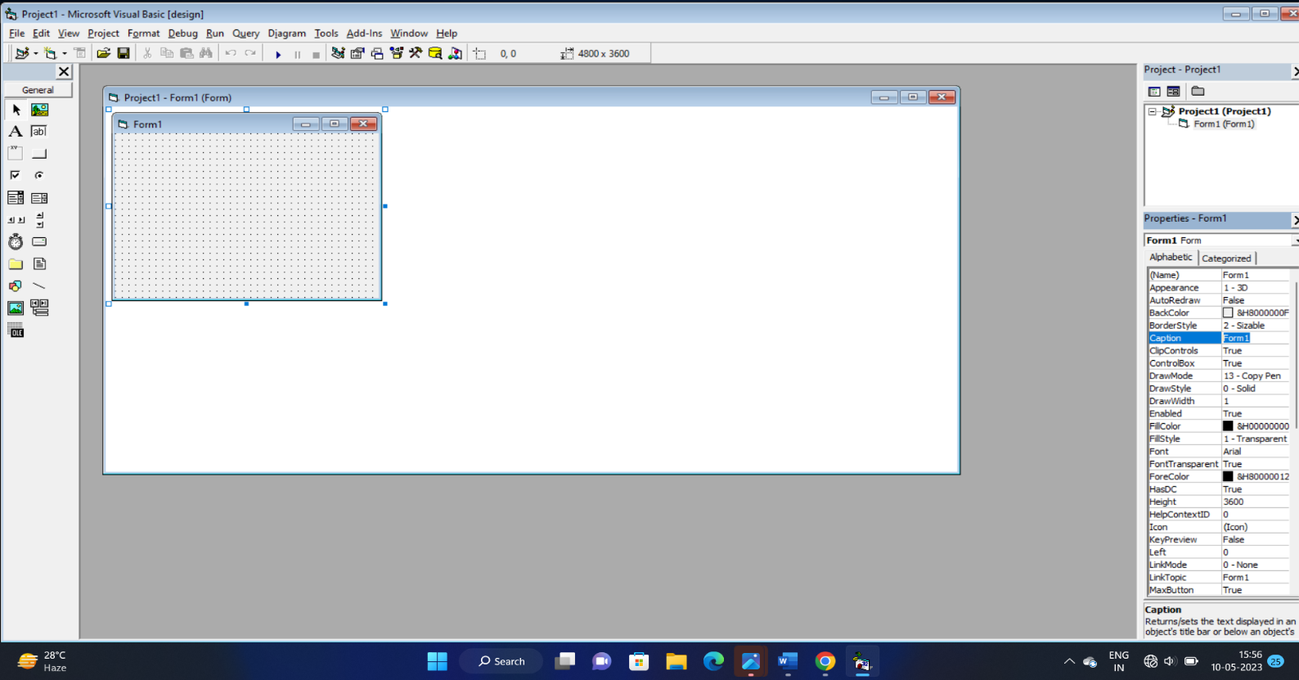

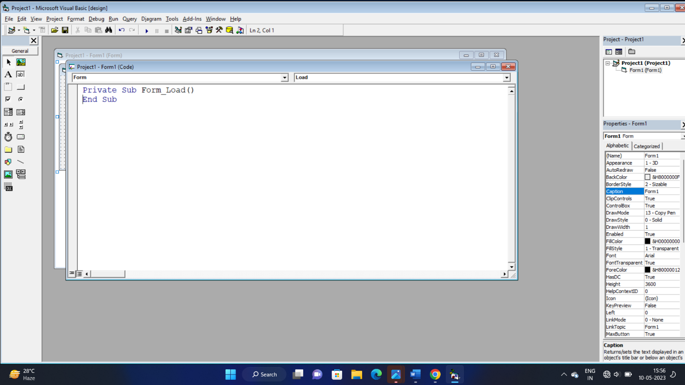

**PROJECT DESIGNING AND CODING:-**

**First of all we make our first form containing portal to choose among one way trip and round trip .**

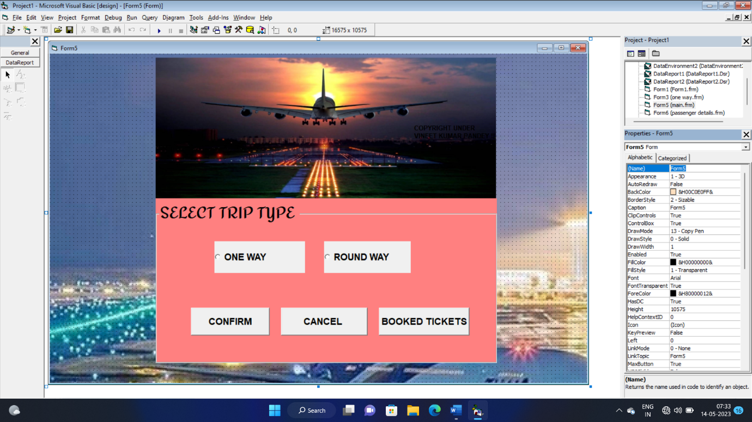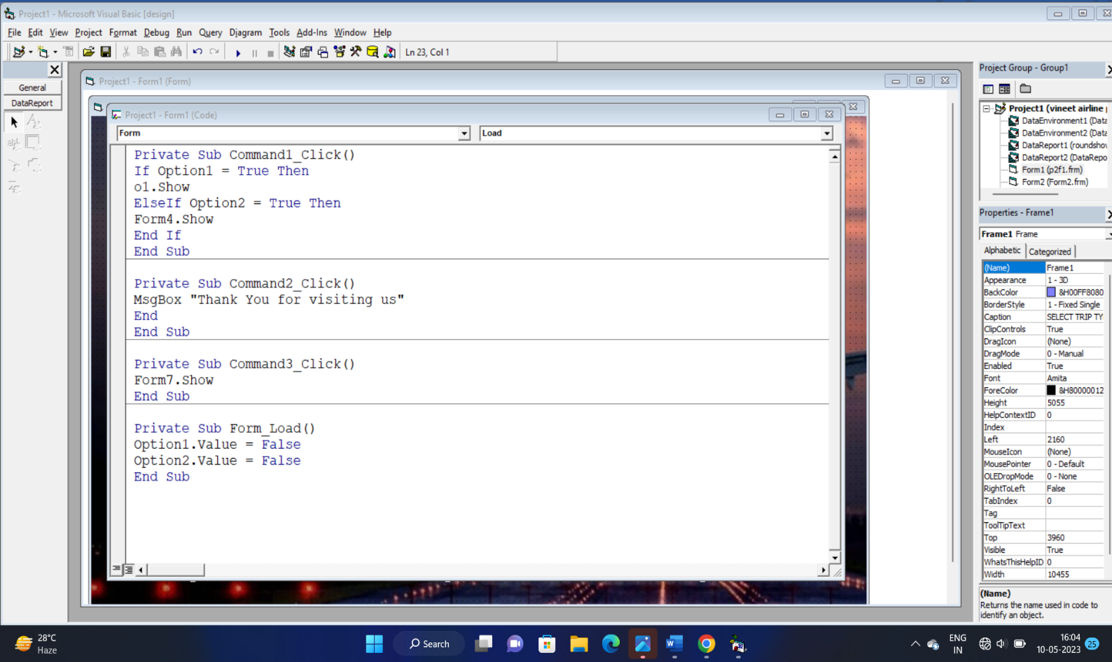

SECOND FORM WINDOW FOR ONE WAY TRIP BOOKING:- In this form we add text boxes to receive input from user ,here we add a date picker to select the proper date of journey ,to take details of all passengers we also added few more labels and text boxes .In this form we have added total four command buttons one to confirm booking ,second to cancel booking and return to first window , third to save details of user , fourth to clear the all filled textboxes and combo boxes.

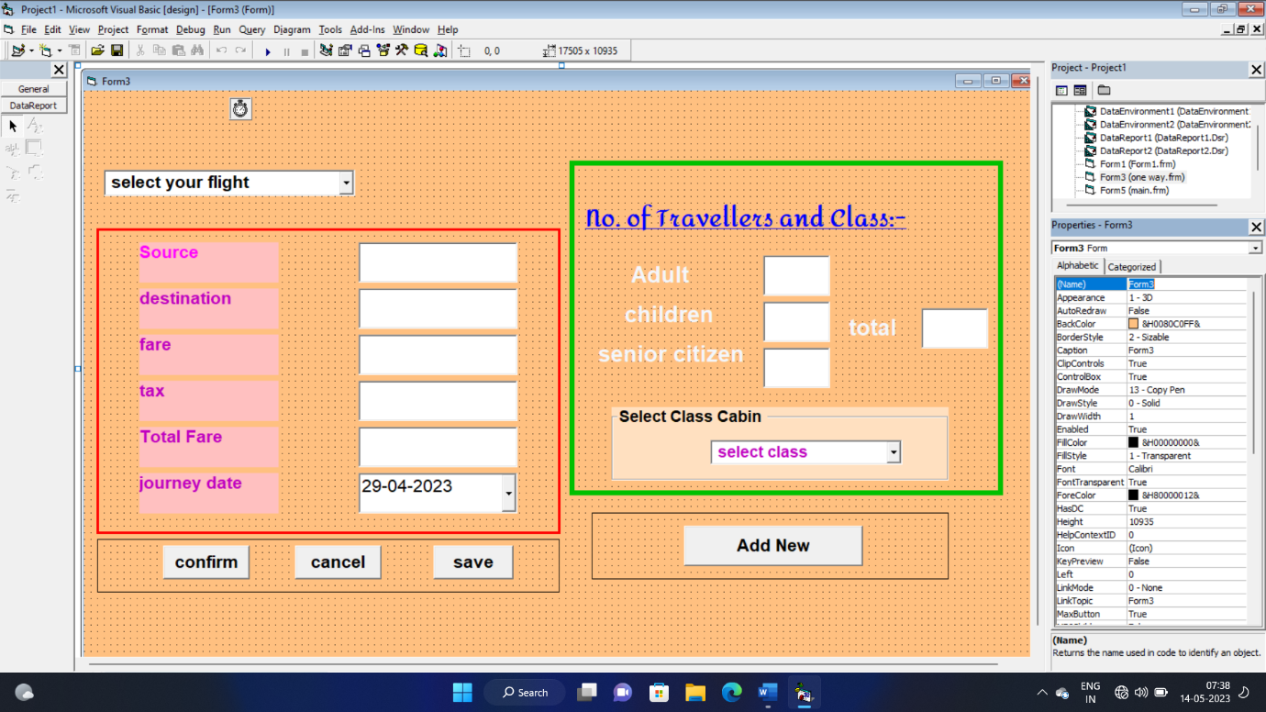

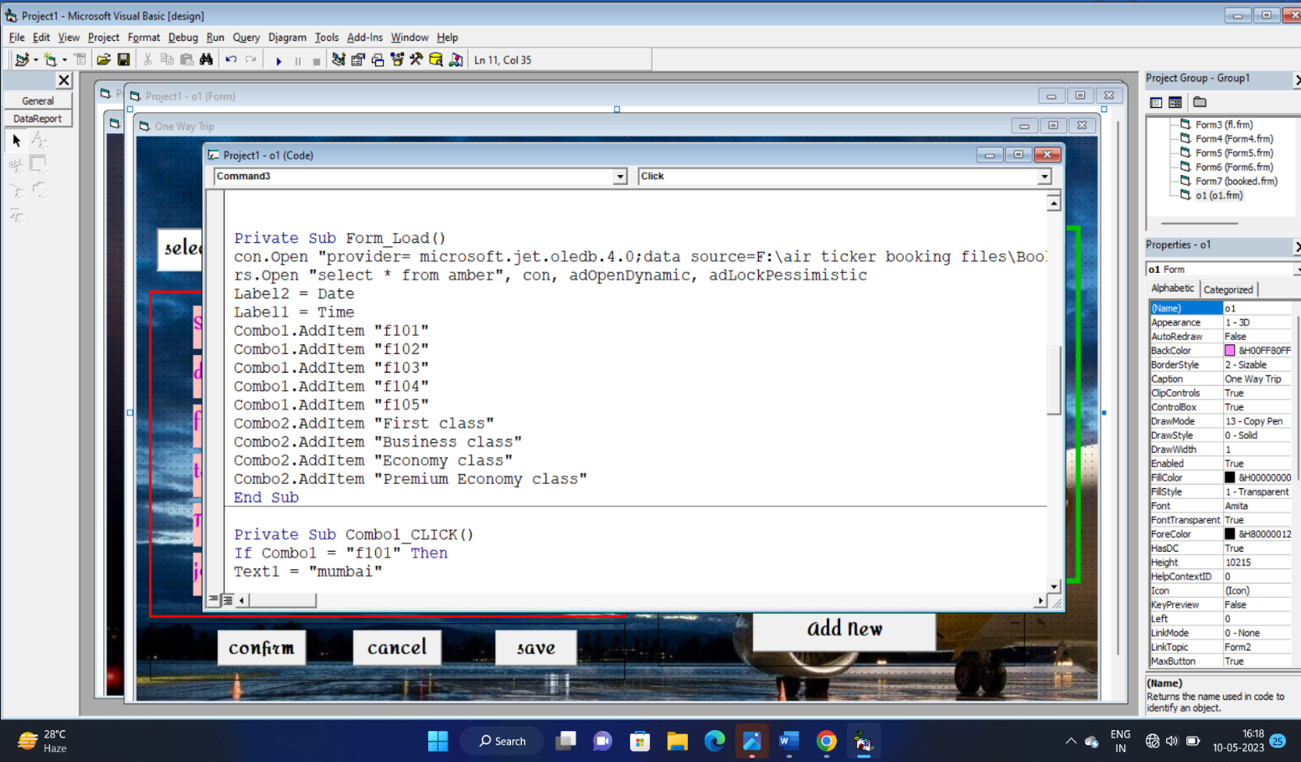

we can not put screenshot of all the coding windows, this one is sufficient for the purpose of illustration, whole code involved into this form is written below:-

Dim con As New ADODB.Connection

Dim rs As New ADODB.Recordset

**Command 3 is used to save the data into our database and to use it for the purpose to check into booked tickets .here’s its codes :-**

Private Sub Command3_Click()

rs.AddNew

rs.Fields("a").Value = Text1.Text

rs.Fields("b").Value = Text2.Text

rs.Fields("c").Value = DTPicker1.Value

rs.Fields("d").Value = Text3.Text

rs.Fields("e").Value = Text4.Text

rs.Fields("f").Value = Text5.Text

rs.Fields("g").Value = Text6.Text

rs.Fields("h").Value = Text7.Text

rs.Fields("i").Value = Text8.Text

rs.Fields("j").Value = Text9.Text

rs.Fields("k").Value = Combo1.Text

rs.Fields("l").Value = Combo2.Text

rs.Fields("m").Value = DTPicker1.Value

MsgBox "data has been saved !!", vbInformation, "flight booked "

rs.Update

End Sub

‘**this code is for addnew button**

Private Sub Command4_Click()

rs.AddNew

clear

End Sub

**'rem we are declaring a sub procedure**

Sub clear()

Text1 = ""

Text2 = ""

DTPicker1 = "29-06-2023"

Text3 = " "

Text4 = " "

Text5 = " "

Combo1 = "select flight "

Combo2 = "select cabin class "

Text6 = " "

Text7 = " "

Text8 = " "

Text9 = " "

End Sub

Private Sub Form_Load()

**Code for adding total passengers and to store value in text 9**

Private Sub Text9_Click()

Text9.Text = Val(Text6.Text) + Val(Text7.Text) + Val(Text8.Text)

End Sub

**‘(this is the code for connecting database )**

**con.Open "provider= microsoft.jet.oledb.4.0;data source=F:\air ticker booking files\Book1.mdb ;Persist security info ="**

**rs.Open "select * from amber", con, adOpenDynamic, adLockPessimistic**

Label2 = Date

Label1 = Time

**Now we will add item to combo boxes based upon which user can proceed further to book ticket**

Combo1.AddItem "f101"

Combo1.AddItem "f102"

Combo1.AddItem "f103"

Combo1.AddItem "f104"

Combo1.AddItem "f105"

Combo2.AddItem "First class"

Combo2.AddItem "Business class"

Combo2.AddItem "Economy class"

Combo2.AddItem "Premium Economy class"

End Sub

**‘Now here is the code for auto selection of destination, origin , fare ,tax , total fare , based upon the flight chosen by user .**

Private Sub Combo1_CLICK()

If Combo1 = "f101" Then

Text1 = "mumbai"

Text2 = "patna"

Text3 = 4500

Text4 = 610

Text5 = Val(Text3) + Val(Text4)

ElseIf Combo1 = "f102" Then

Text1 = "BADODARA"

Text2 = "mumbai"

Text3 = 8000

Text4 = 650

Text5 = Val(Text3) + Val(Text4)

ElseIf Combo1 = "f103" Then

Text1 = "varanasi"

Text2 = "mumbai"

Text3 = 5000

Text4 = 650

Text5 = Val(Text3) + Val(Text4)

ElseIf Combo1 = "f104" Then

Text1 = "patna"

Text2 = "ahmedabad"

Text3 = 5500

Text4 = 700

Text5 = Val(Text3) + Val(Text4)

ElseIf Combo1 = "f105" Then

Text1 = "mumbai"

Text2 = "varanasi"

Text3 = 8000

Text4 = 700

Text5 = Val(Text3) + Val(Text4)

End If

End Sub

**Code for the confirm button by clicking on which user can get to see a new form open where he can enter the passenger’s details .**

Private Sub Command1_Click()

MsgBox "please provide passenger details ,thank you. "

Form6.Show

End Sub

**Code for the cancel button by clicking on which user can get exited**

Private Sub Command2_Click()

MsgBox "THANK YOU FOR VISITING US"

End

End Sub

Above code will be used to make the cancel command button end the program.

Below is the layout of form6 used for taking details of passengers :

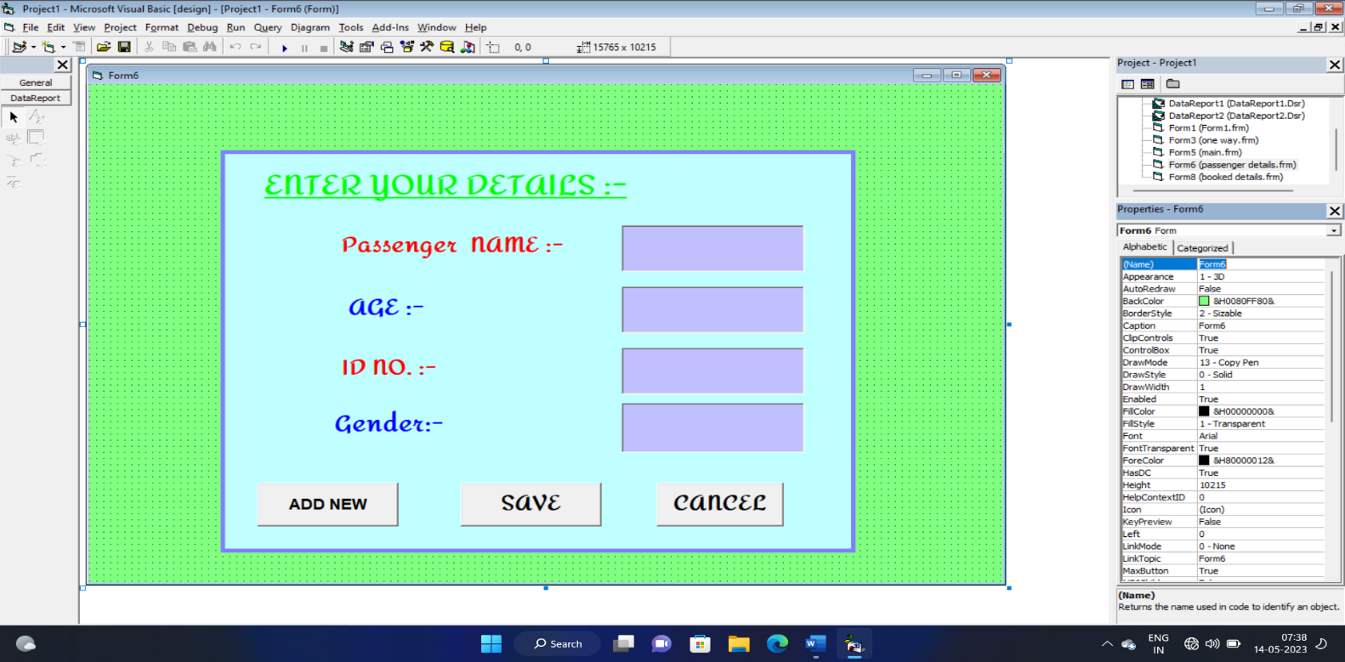

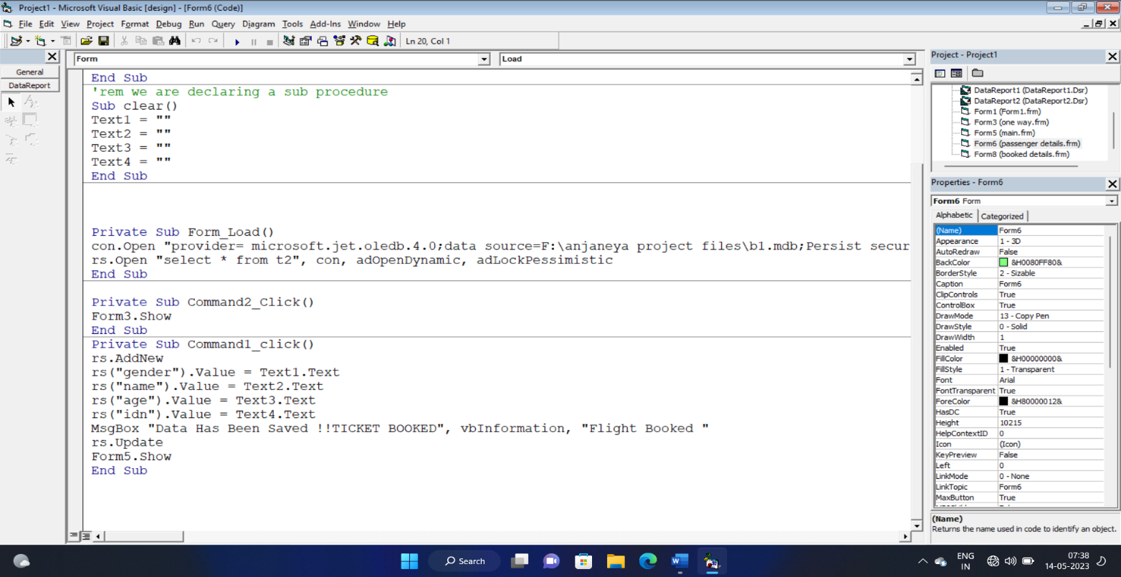

This above form is used to take input from user and save it to the database, after successful completion of this form user got message of his booked ticket. He can see his booking details from the booked tickets corner.

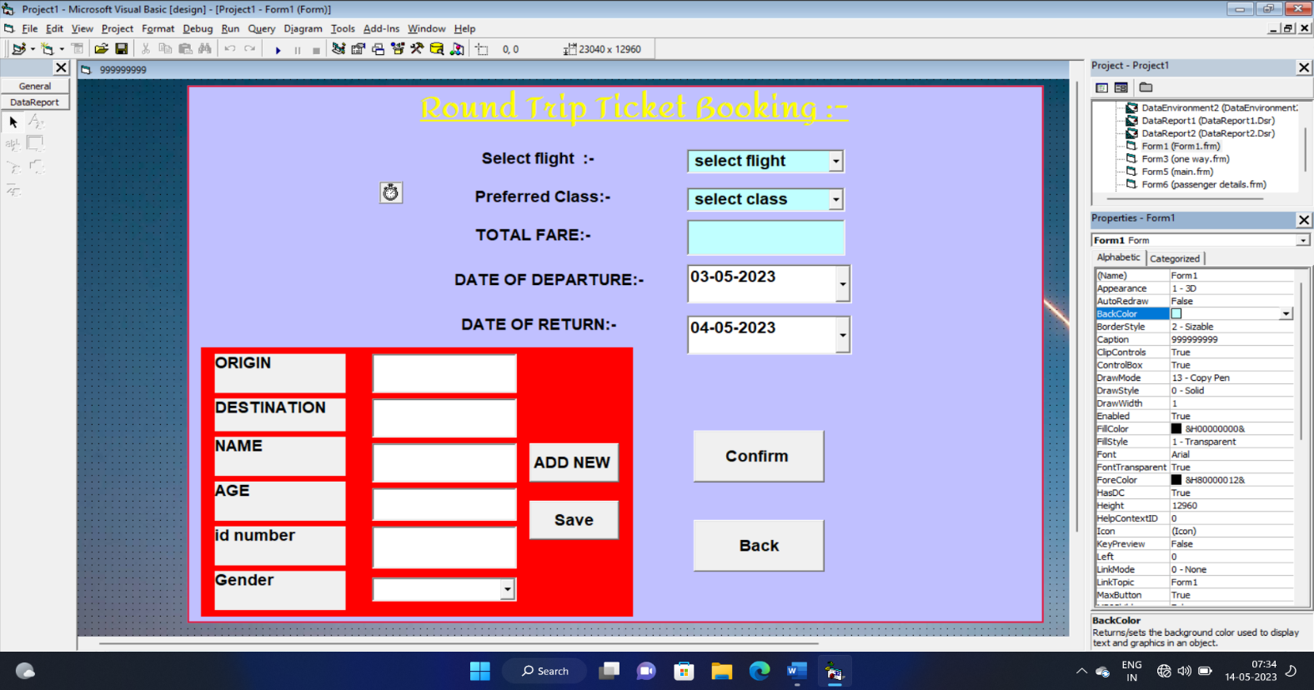Now we will see the booking window of round trip booking :-

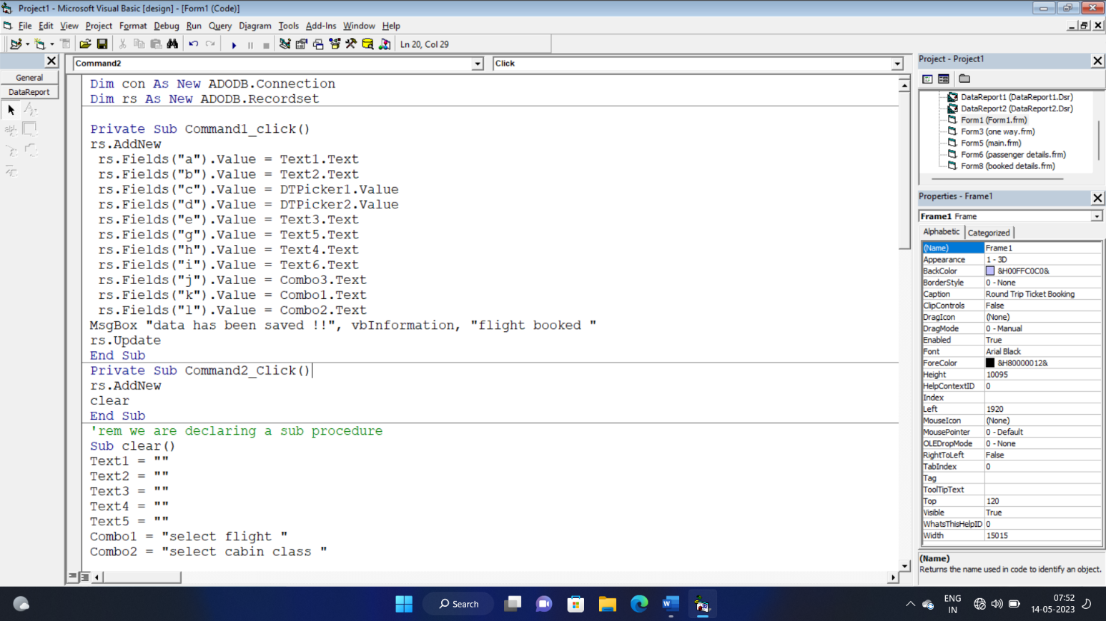

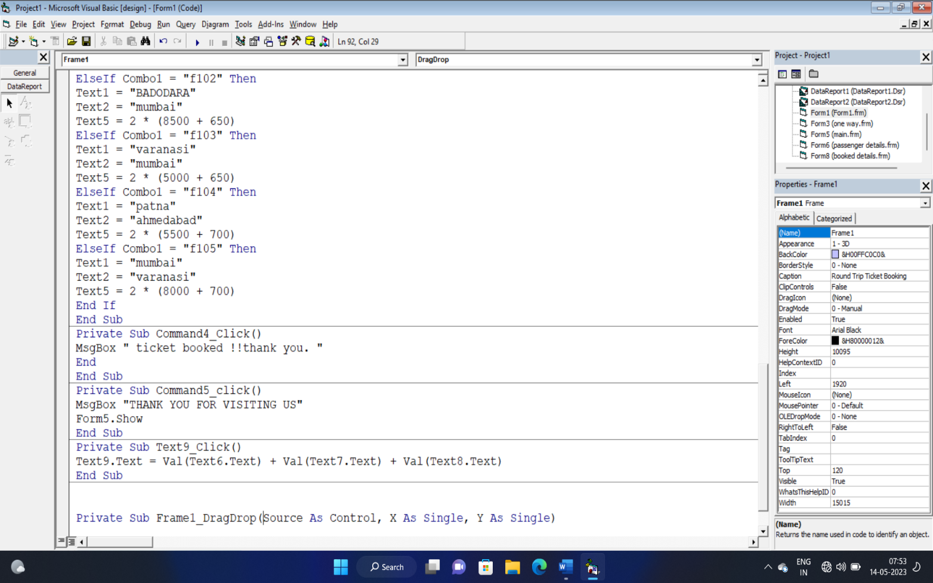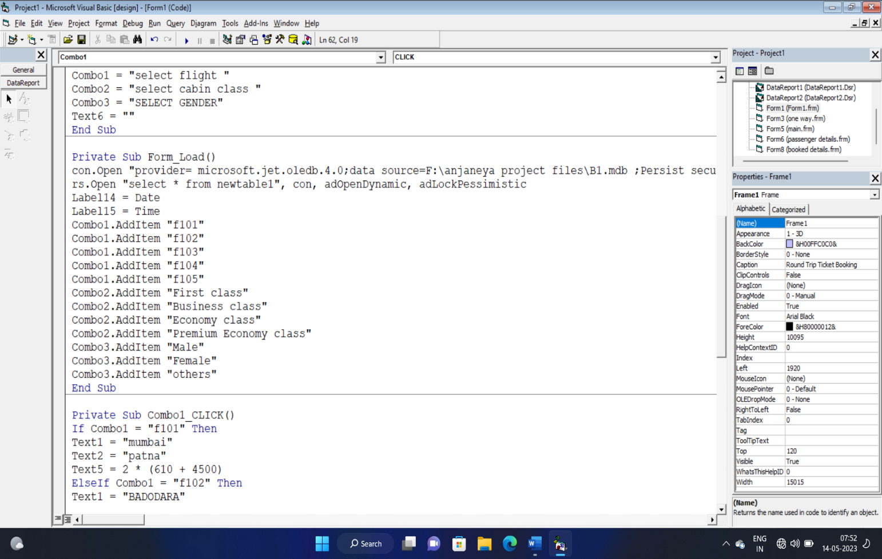

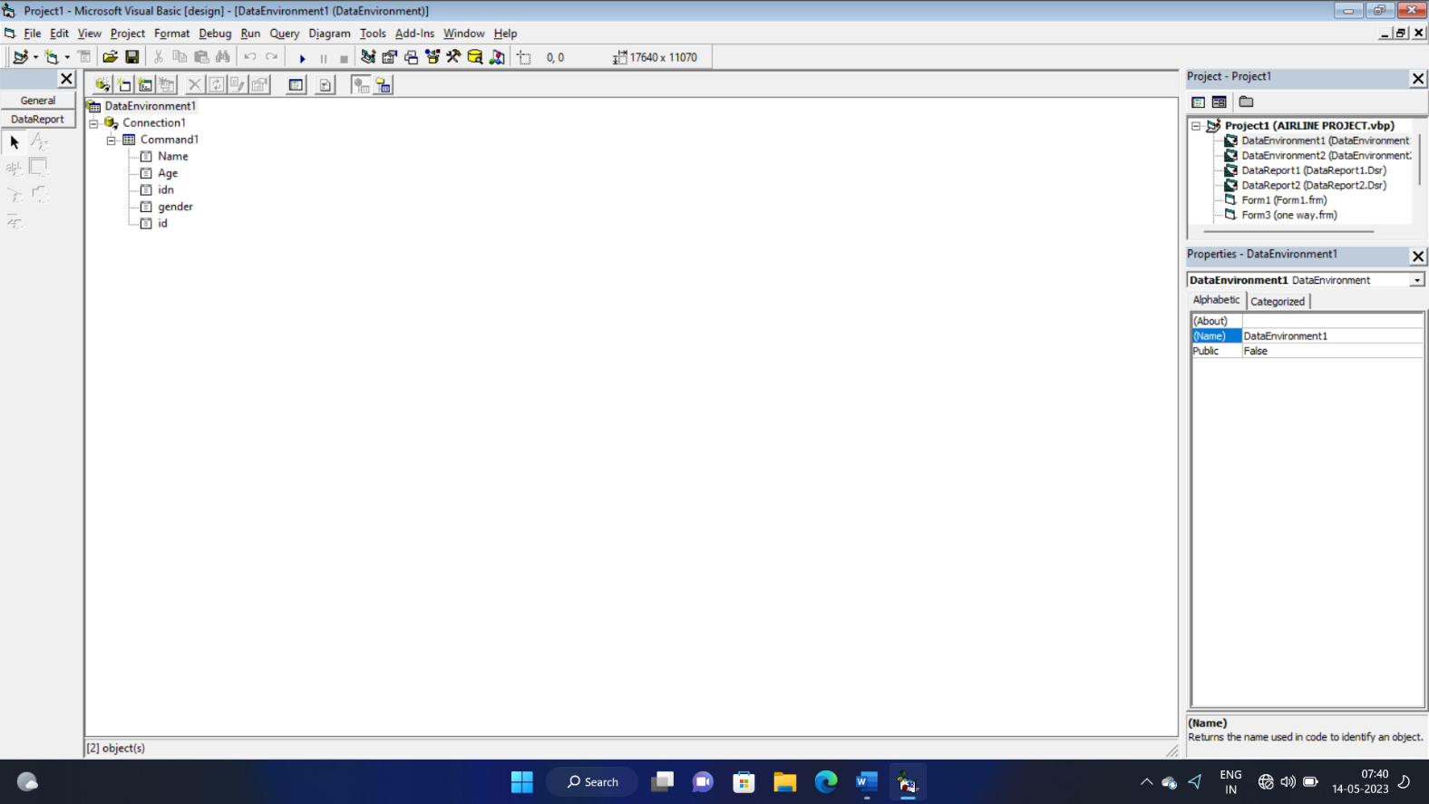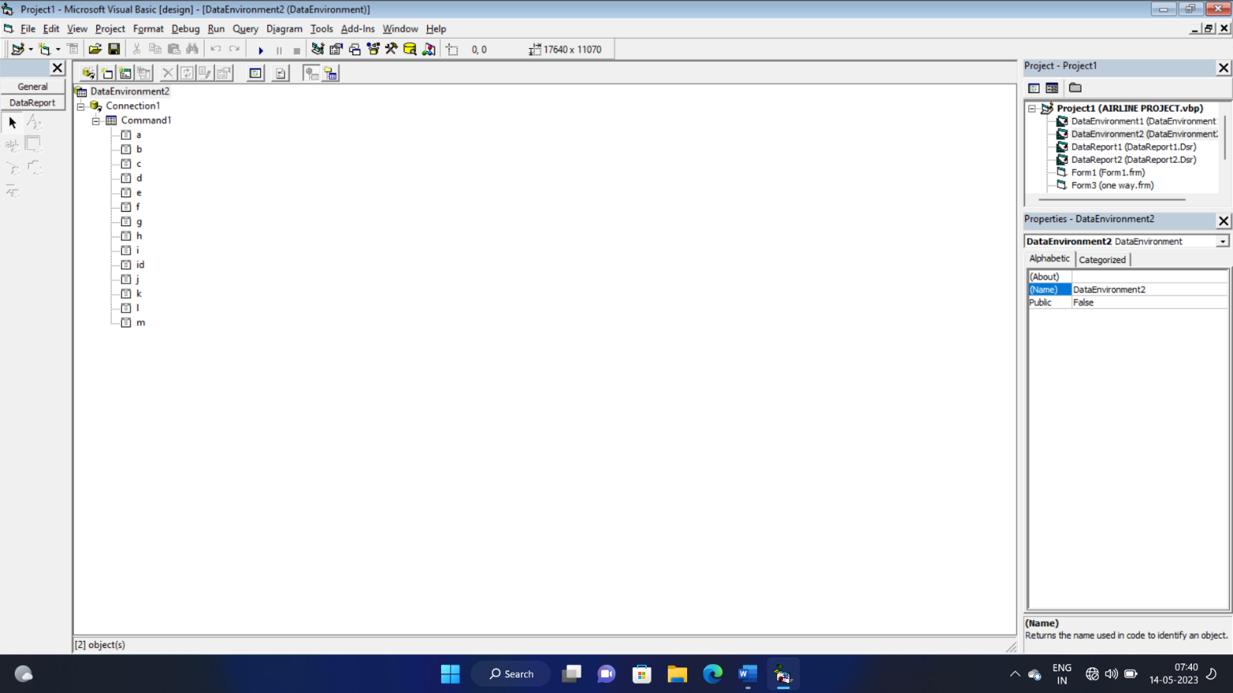**Now we have created data environment and make data reports and established connection with our database where we have already saved passenger’s details.**

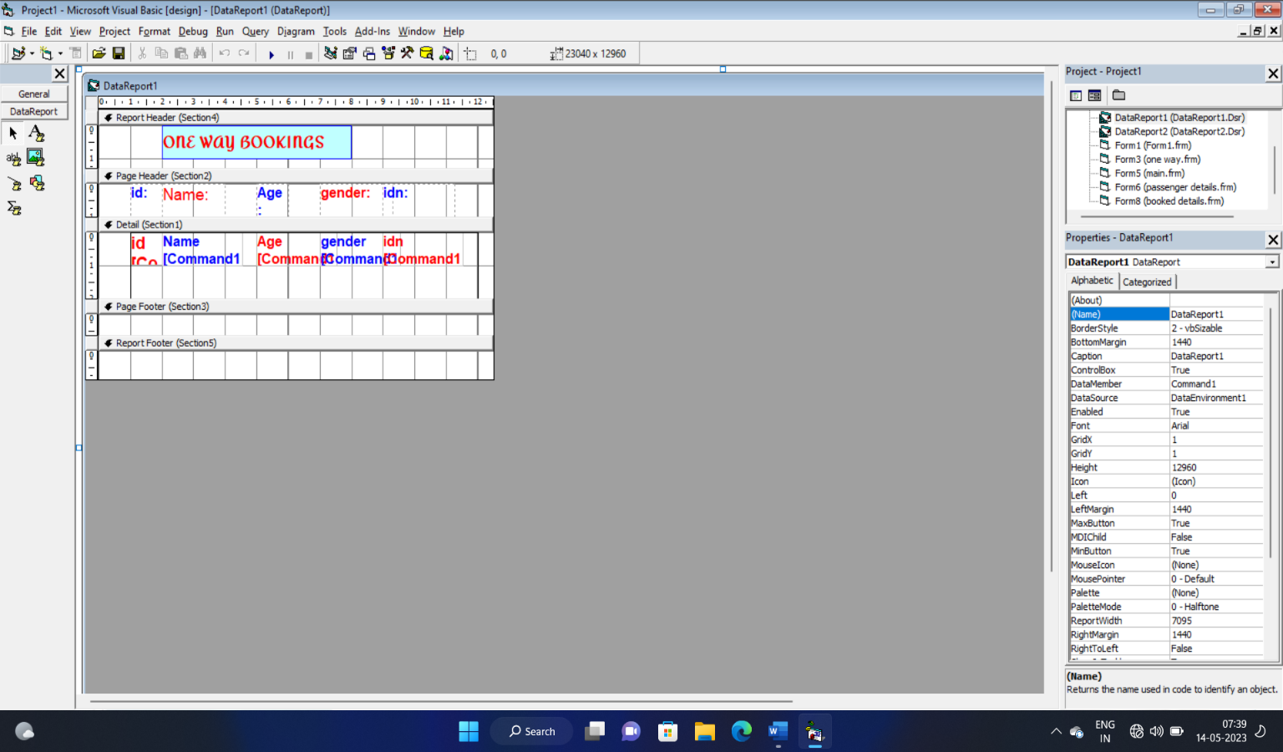

Above shown is the window of data report1 and the below illustrated pic shows the datareport2

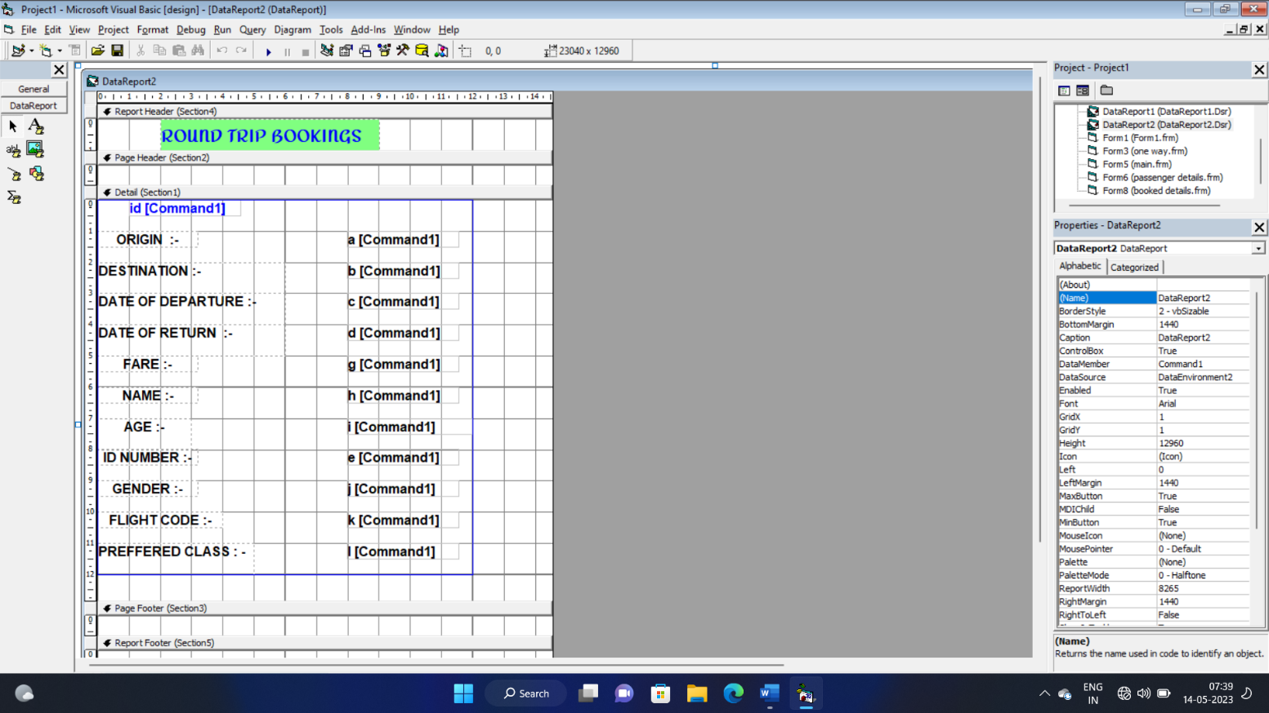

**Here is the window of the form that show the booked tickets details. User will get two option to select from :**

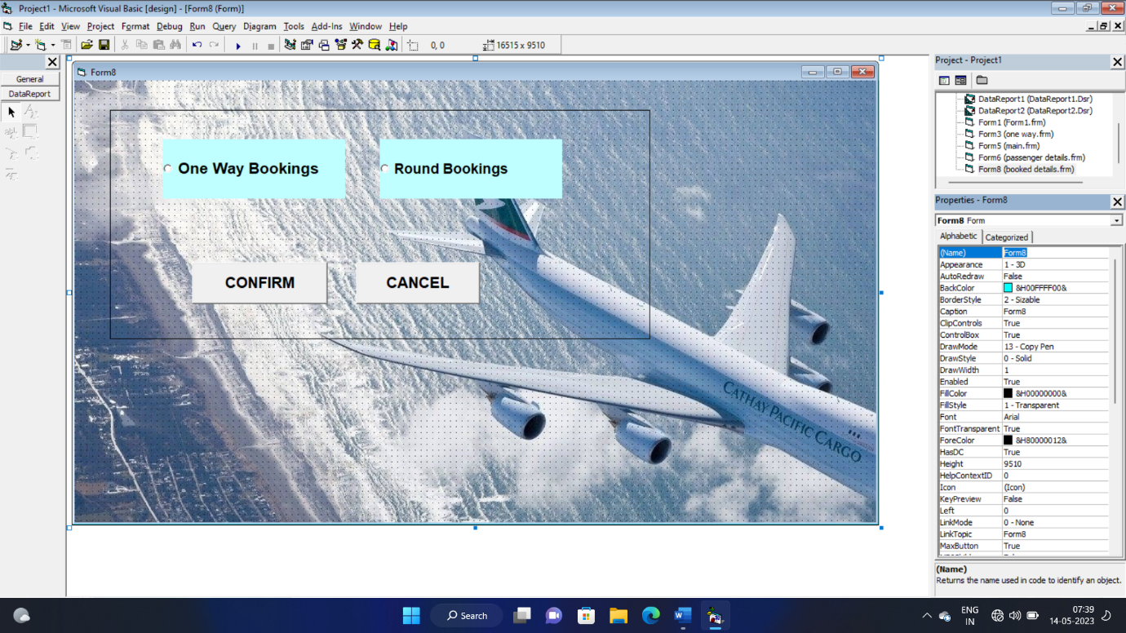

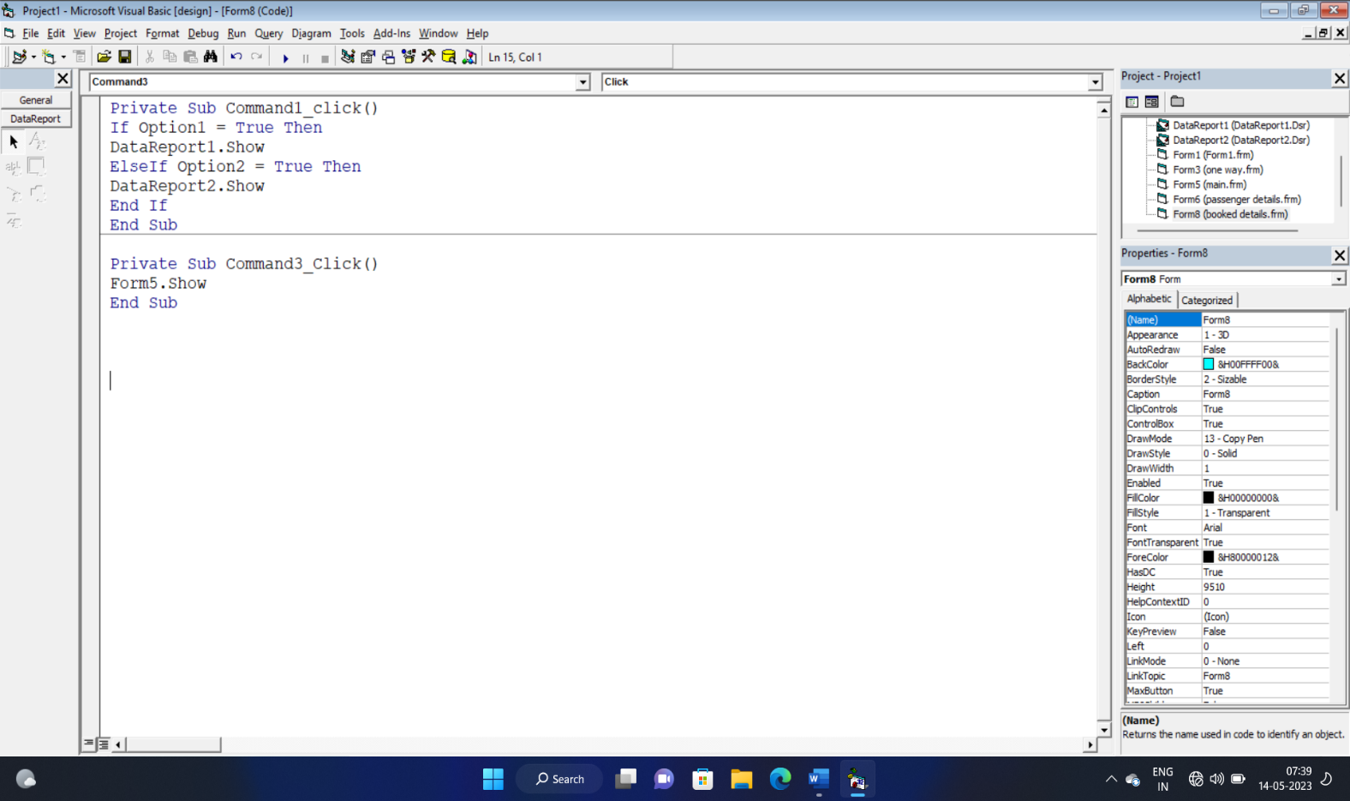

Here due to inefficiency of system and lack of time wi have only added two payment methods but that may be sufficient . After successful completing

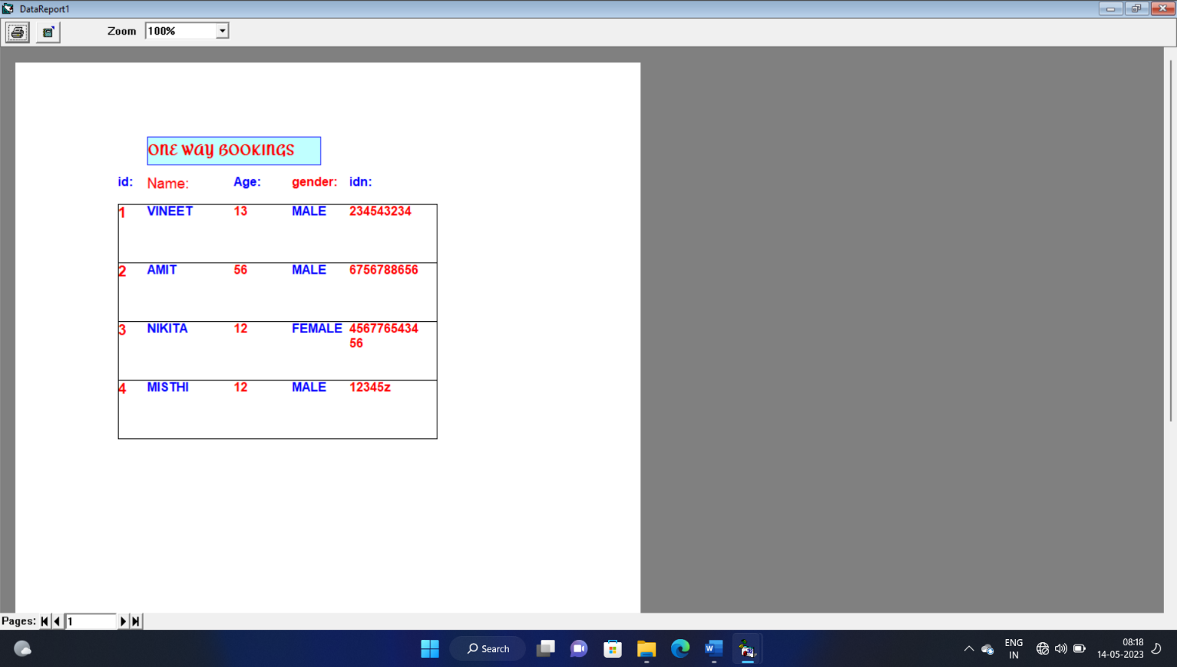

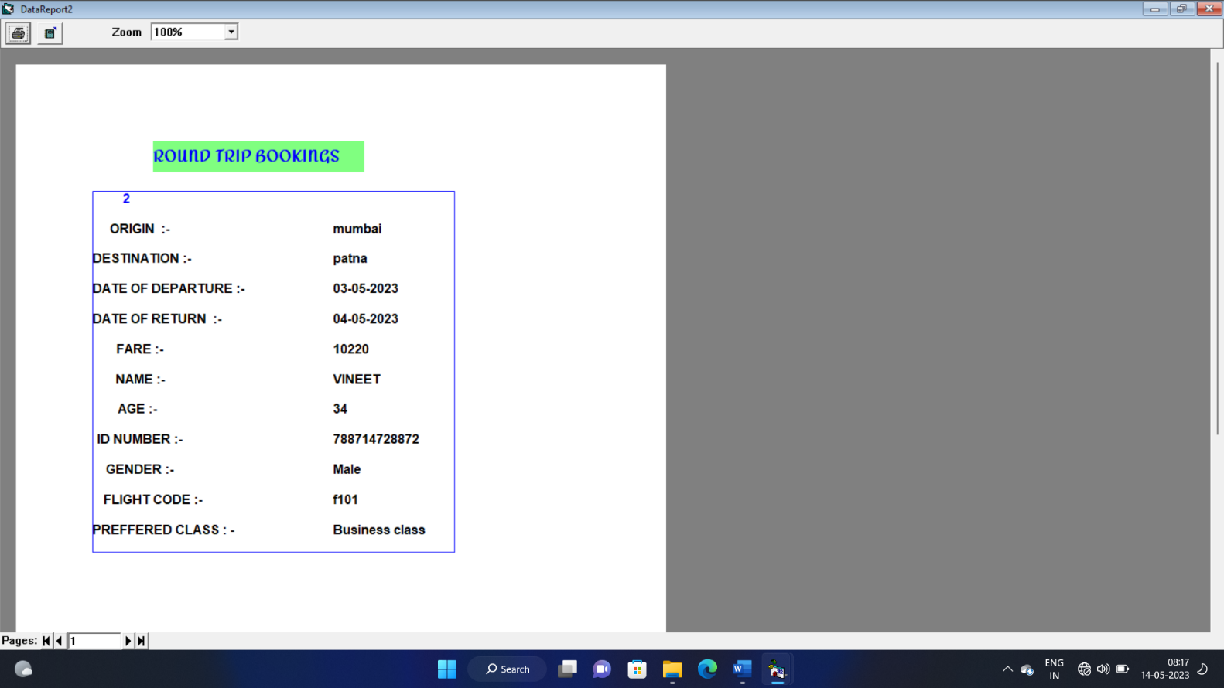**Above is the window of one way trip booked tickets details :**

This is window of booked tickets for round trip :-

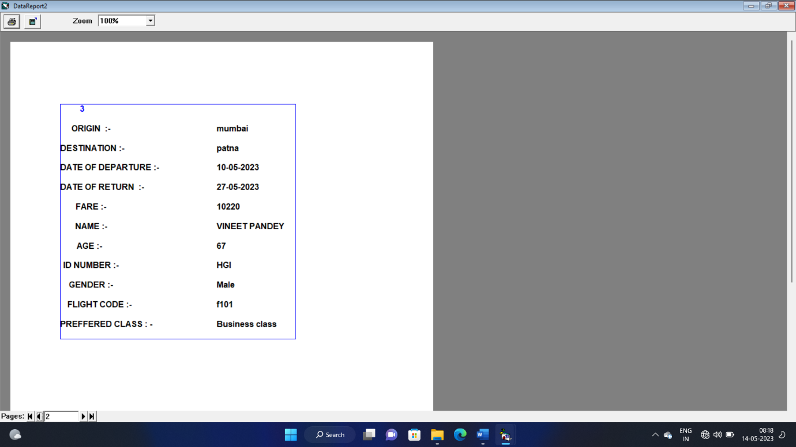

Thus we have successfully created all the forms and established its connection with database .now we will save our project with desired name .After successfully debugging ,we have made our project to run finally.

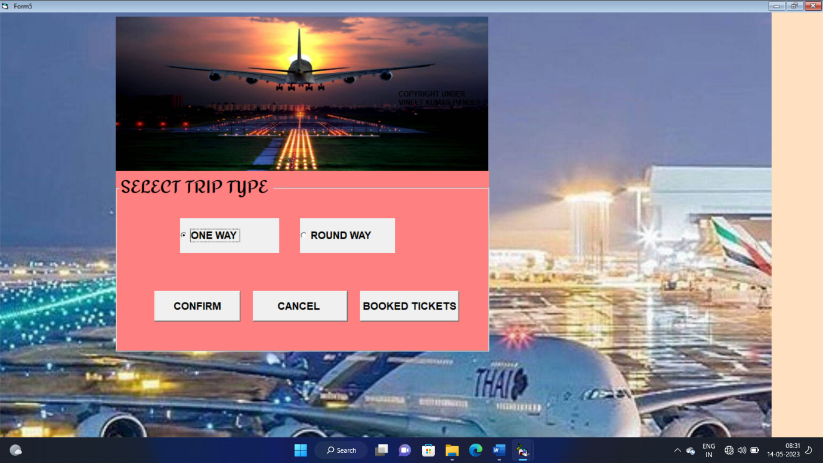Now we will see the output from our project :-

Selecting option one way and by clicking on confirm button the form of one way has got opened. where user enter the details and select his/her flight.

[Grab your reader’s attention with a great quote from the document or use this space to emphasize a key point. To place this text box anywhere on the page, just drag it.]

[Grab your reader’s attention with a great quote from the document or use this space to emphasize a key point. To place this text box anywhere on the page, just drag it.]

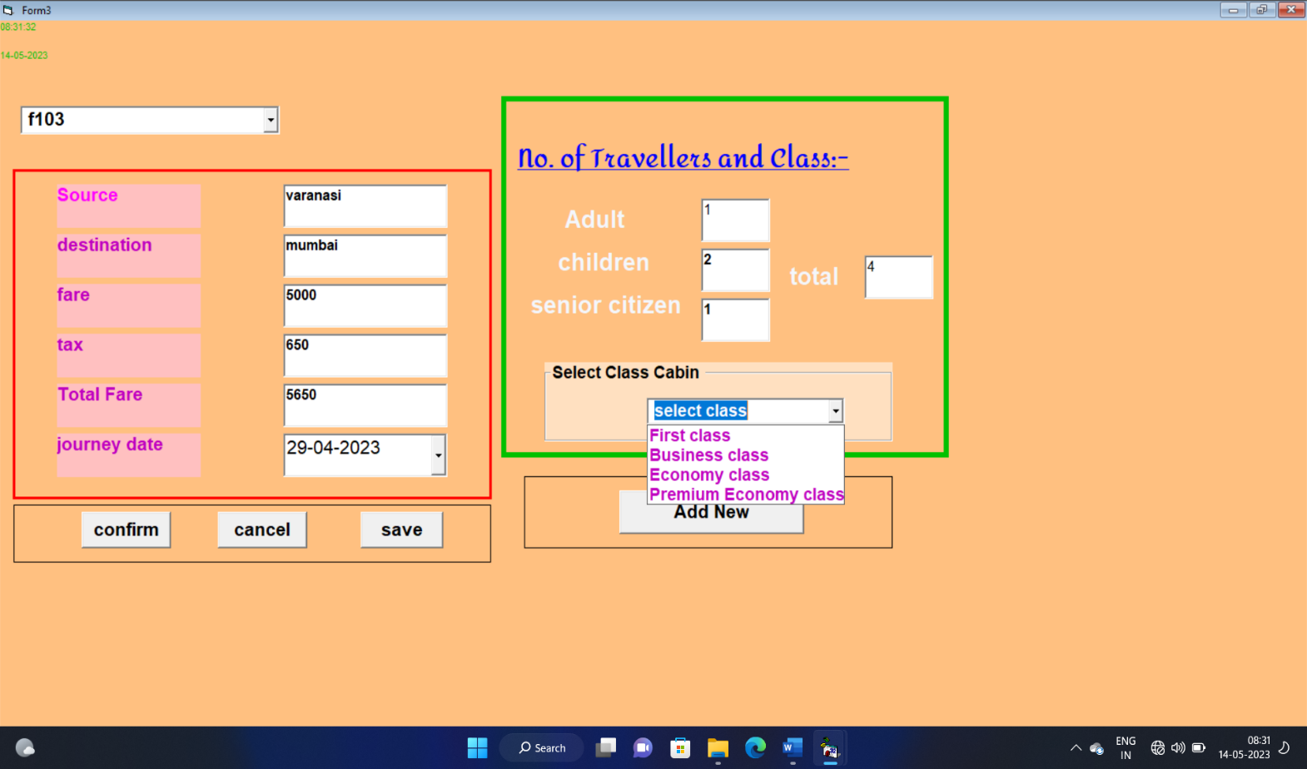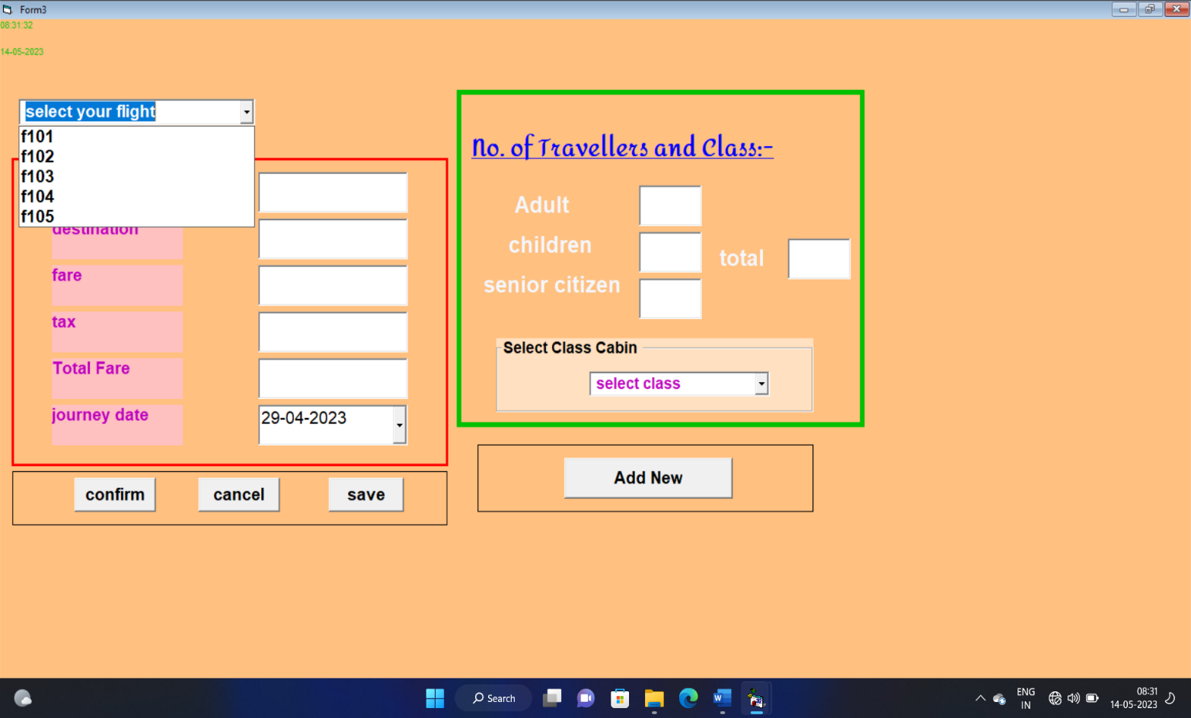

User can enter the total number of passenger’s on the same window .He will select the cabin class. Then click on save .

We will select flight code from combo box 1 .After selecting flight code the origin, destination , fare column code automatically filled. User will select the date of journey from the datepicker .

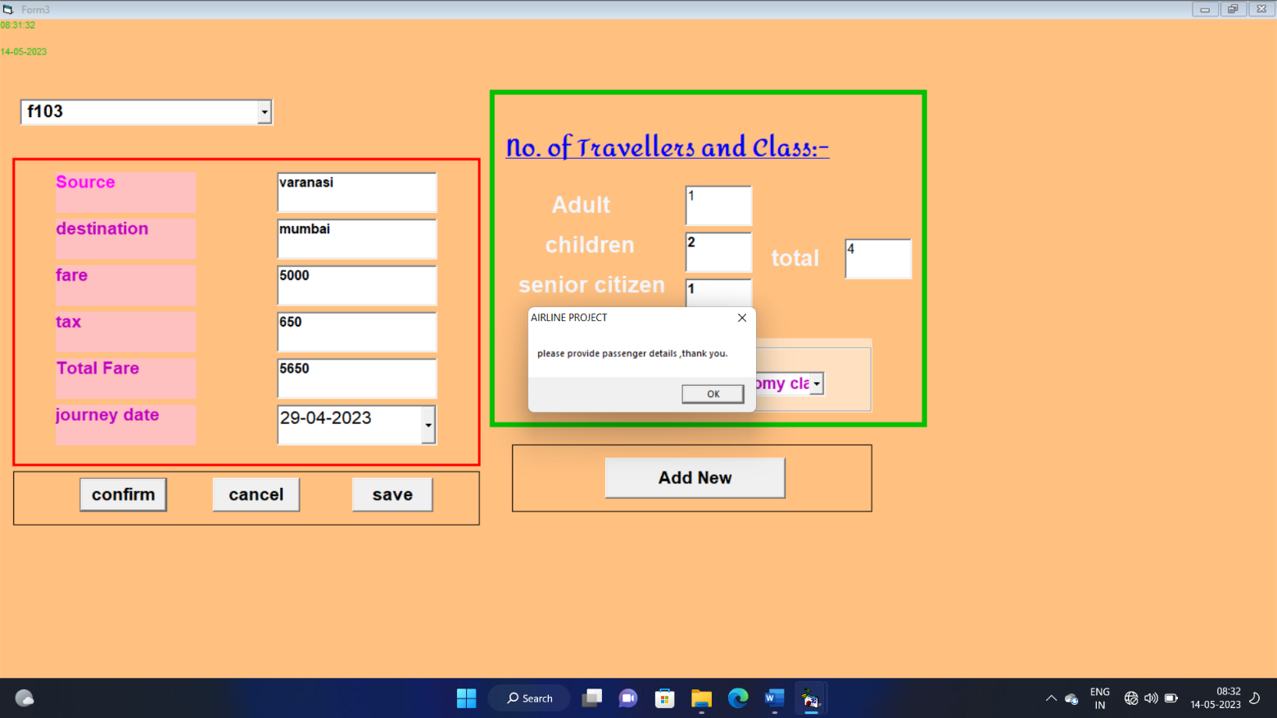

Clicking on saveUser will see a Dialogue box “data has been saved” . now when click on confirm he got a msg of “please provide passenger’s details “

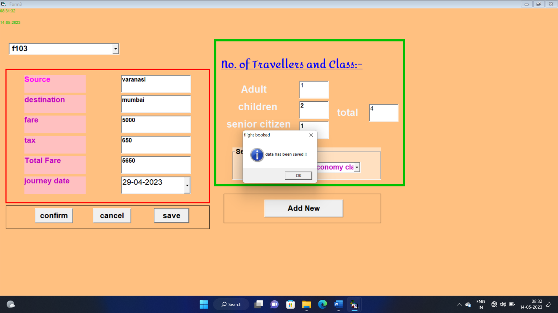

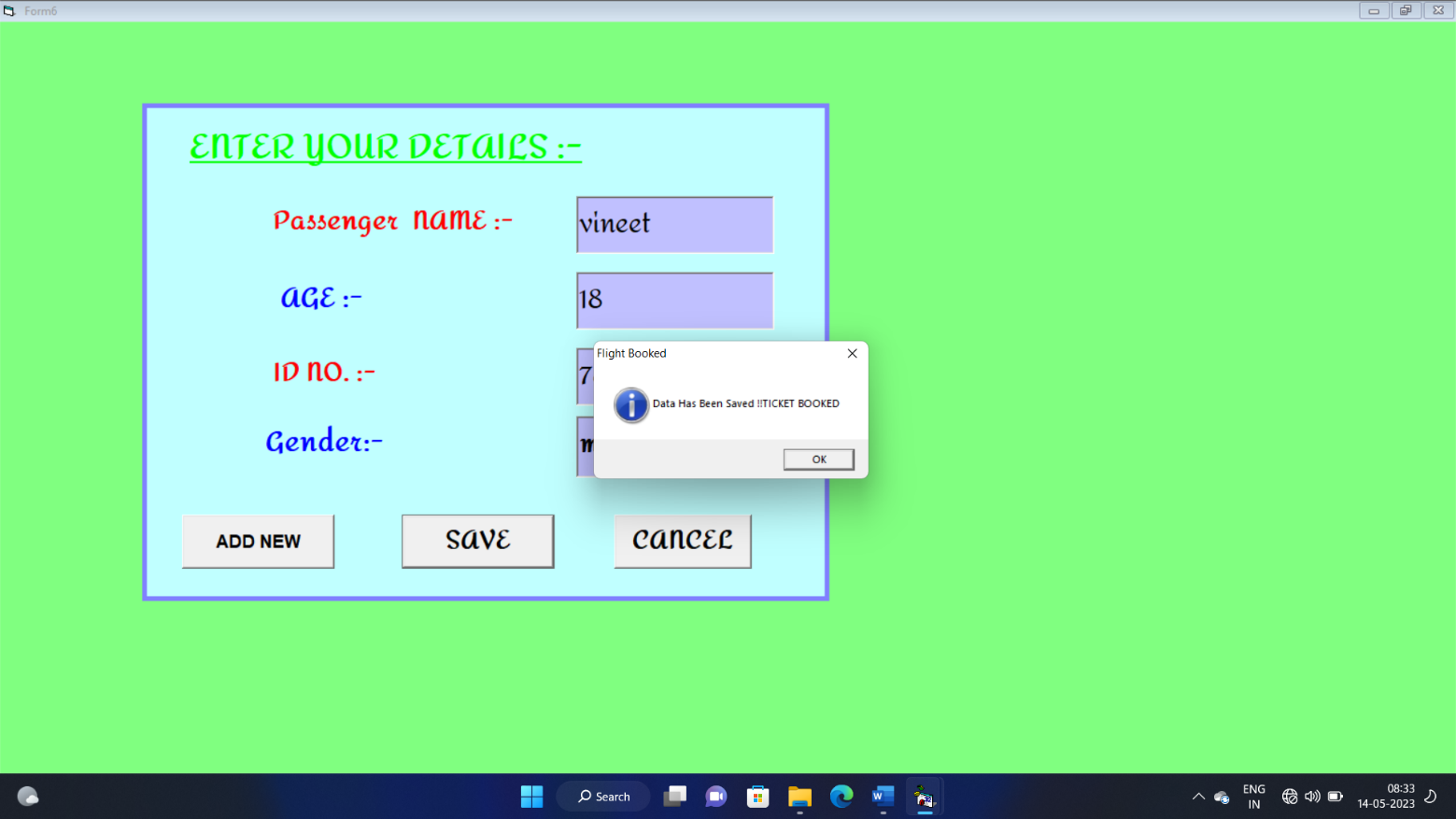

After filling passenger’s details user can save the information or click on add new to add more passengers. After filling all passenger’s, he will click on save. After clicking on save he will get msg that ticket booked.

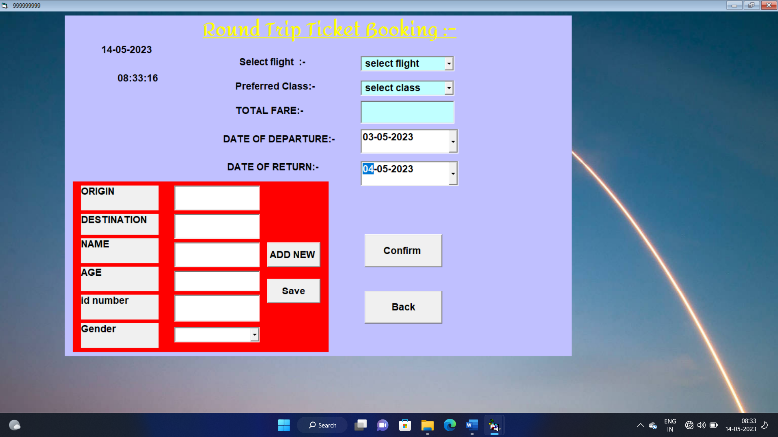

On the starting page of our program WHEN USER SELECT ROUND TRIP then this form will get opened . In this form user can enter all data and click on save or add new if more passenger’s to be added . Then, at last He will click on Confirm button. And got a msg that ticket will be booked.

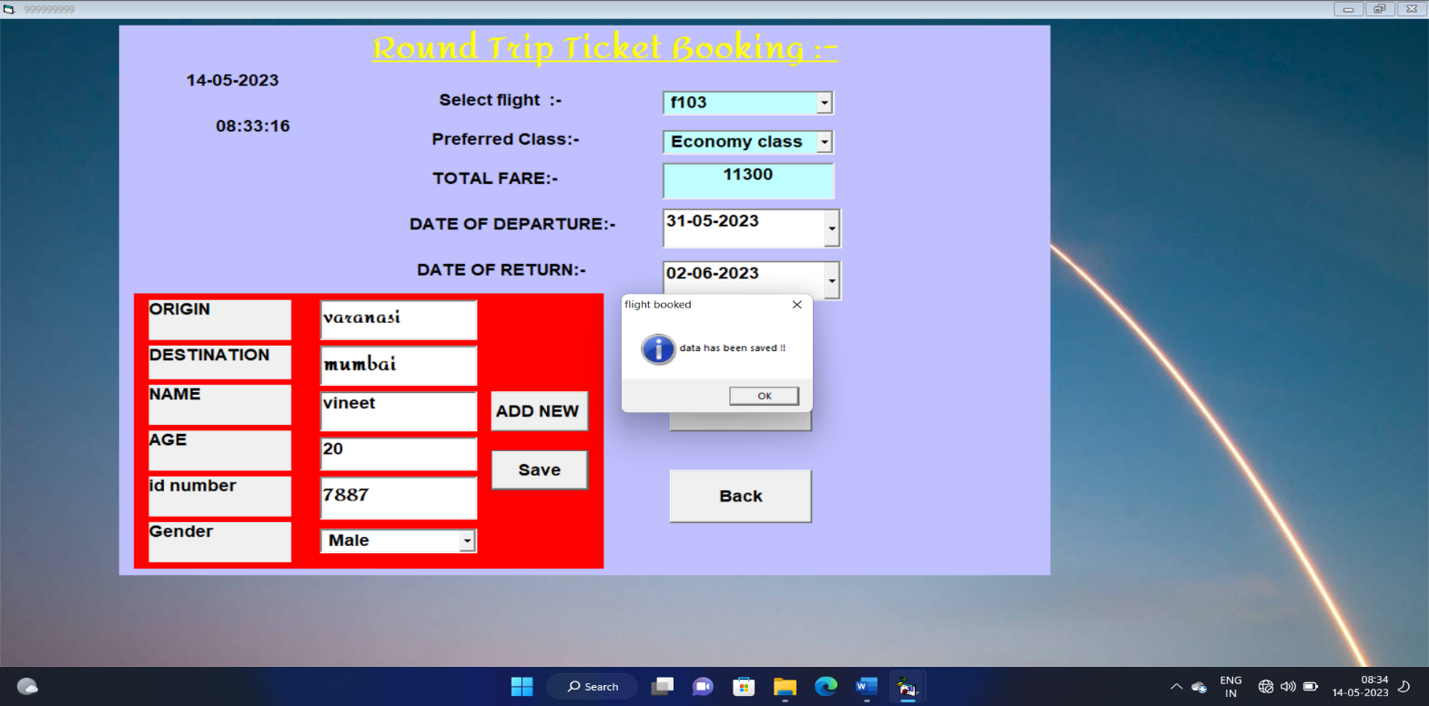

User will be able to see all his booked tickets on booked tickets option at the starting portal of our project process will be shown earlier .

**CONCLUSION**

This system has limited area of its operation so it does not deal with entire automation of the application because of lack of time.

Some modification can take place such as, addition of more payment methods, calculator for auto fare calculation, more cities for a wider option, online connectivity with server etc.

**Bibliography:-**

1. VISUAL BASIC 6.0 COMPLETE REFERENCE
2. VISUAL BASIC 6.0 BLACK BOOK.
3. MS OFFICE BY MICROSOFT CORPORATION.

"THANKING YOU"